Robert Bara

**HW3**

1. Use Link-state and distance vector algorithms to find the short paths from the ”source” node  
   to other nodes in fig. 1. Describe each of your steps of the algorithms. Coding is not required.
2. Assume you would like to set a VPN from the source to connect to another node through a  
   VPN server in this network fig. 1, how do you do it? Please describe each step and point out  
   the difference between the shortest path and the path when you’re using VPN.

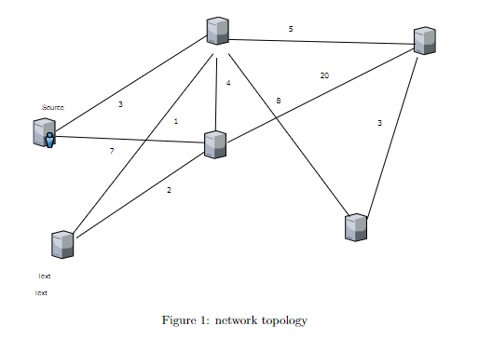



1. If I assign a number to each node as shown in the annotation above, the shortest path from the source to each node is as follows:
   1. N0->N1: 7
   2. N0->N2:3+1=4
   3. N0->N3: 3+8=11
   4. N0->N4: 3+5=8
   5. N0->N5: 3
2. I would assign N1 to be the VPN, which is going to affect the node paths as follows:
   1. N0->VPN->N1: 7 Path is about the same distance
   2. N0->VPN->N2:7+2=9 Path is 5 longer than without the VPN
   3. N0->VPN->N3: 7+4+5=19 Path is 5 longer than without the VPN
   4. N0->VPN->N4: 7+4+5=16 Path is 8 longer than without the VPN
   5. N0->VPN->N5: 7+4=11 Path is 8 longer than without the VPN